**OEE351-RENEWABLE ENERGY SYSTEM**

**UNIT - 5 OTHER TYPES OF ENERGY**

**1. Discuss the principles and processes involved in energy conversion from hydrogen and fuel cells**

**Introduction**

Hydrogen is a clean and renewable energy carrier that can be used to produce electricity. A **fuel cell** is a device that converts the chemical energy of hydrogen into **electricity and heat** through a chemical reaction with oxygen — without combustion. This process is highly efficient and emits only **water vapor** as a by-product.

**I. Principles of Hydrogen Energy Conversion**

**1. Hydrogen as an Energy Carrier**

* Hydrogen is not a source of energy, but an **energy carrier**.
* It can be produced from various resources such as **water**, **natural gas**, **biomass**, or by **electrolysis** using solar/wind energy.
* It is clean, non-toxic, and can store and deliver large amounts of energy.

**2. Basic Principle of Energy Conversion**

* The basic principle is the **electrochemical reaction** of hydrogen (H₂) with oxygen (O₂) to form water (H₂O).
* This reaction releases **electrons**, which flow through an external circuit as **electricity**.
* The overall chemical reaction in a fuel cell is:

2H2 + O2 → 2H2O + Energy ( Electricity+ Heat )

**II. Processes Involved in Hydrogen Production and Conversion**

**1. Hydrogen Production Methods**

* **Electrolysis**: Water (H₂O) is split into hydrogen and oxygen using electricity.
  + H₂O → H₂ + ½O₂
  + When electricity from **renewable sources** is used, the process is 100% green.
* **Steam Methane Reforming (SMR)**: Hydrogen is extracted from natural gas.
  + CH₄ + H₂O → CO + 3H₂
  + Widely used, but emits some CO₂ unless carbon capture is added.
* **Biomass Gasification**: Organic matter is heated in low oxygen to produce a mixture of hydrogen and other gases.
* **Photolysis and Biological Methods**: These are advanced methods still under research for splitting water using sunlight or microbes.

**2. Hydrogen Storage and Transportation**

* Hydrogen is stored in three ways:
  + As a **compressed gas**
  + As a **liquid** at cryogenic temperatures
  + As a **solid compound** (e.g., metal hydrides)
* It is transported via **cylinders**, **pipelines**, or **on-site generation systems**.

**3. Fuel Cell Working Process**

A **fuel cell** consists of three main components: the **anode**, the **cathode**, and the **electrolyte**.

* **At the Anode**:
  + Hydrogen gas (H₂) is fed into the fuel cell.
  + It is split into **protons (H⁺)** and **electrons (e⁻)** by a catalyst.
  + Electrons flow through an external circuit to produce electricity.
* **At the Cathode**:
  + Oxygen (from air) combines with the protons (H⁺) and electrons (e⁻) to form **water**.
* The electrolyte only allows protons to pass through, forcing electrons to travel through the external circuit (which generates electricity).

**4. Types of Fuel Cells**

* **Proton Exchange Membrane Fuel Cell (PEMFC)**: Used in vehicles and portable devices.
* **Solid Oxide Fuel Cell (SOFC)**: Operates at high temperature; used for stationary power generation.
* **Alkaline Fuel Cell (AFC)**, **Phosphoric Acid Fuel Cell (PAFC)**, etc.

**III. Advantages of Hydrogen and Fuel Cells**

1. **Clean Energy**:
   * Zero harmful emissions — only water is produced.
   * Ideal for reducing air pollution and greenhouse gases.
2. **High Efficiency**:
   * Fuel cells are more efficient (40–60%) than combustion engines.
3. **Quiet Operation**:
   * No noise pollution because there are no moving parts.
4. **Scalability**:
   * Can be used for small devices (like laptops) or large applications (like vehicles and power plants).
5. **Energy Storage**:
   * Hydrogen can store excess renewable energy for later use.

**IV. Challenges and Limitations**

1. **Hydrogen Storage**:
   * Requires high pressure or very low temperatures — both are costly and complex.
2. **Production Cost**:
   * Green hydrogen (via electrolysis) is still expensive compared to fossil fuels.
3. **Infrastructure**:
   * Lack of hydrogen refueling stations and transport pipelines.
4. **Fuel Cell Durability**:
   * Some fuel cells degrade over time and need high-purity hydrogen.

**Conclusion**

Hydrogen and fuel cells offer a promising path to a clean and sustainable energy future. With advancements in production, storage, and infrastructure, hydrogen can become a **key solution** to the world's growing energy demands while reducing pollution and carbon emissions. They are especially important in sectors like **transport**, **backup power**, and **renewable energy storage**.

**2. Analyze the different methods of harnessing geothermal energy and its potential in India.**

**I. What is Geothermal Energy?**

Geothermal energy is the **heat energy stored beneath the Earth’s surface**. This heat comes from:

* The **natural radioactive decay** of elements inside the Earth,
* **Residual heat** from Earth’s formation,
* And the movement of **magma and hot rocks**.

This heat can be extracted and converted into **electricity**, used for **heating**, or in **industrial processes**.

**II. Methods of Harnessing Geothermal Energy**

There are **three main methods** to harness geothermal energy based on the temperature and type of geothermal resource:

**1. Dry Steam Power Plants**

* **Oldest and simplest method** of harnessing geothermal energy.
* Use **steam directly from underground reservoirs** to turn turbines and generate electricity.
* No water separation or heat exchange is required.

**Example:** The Geysers geothermal field in California, USA.

**Limitation:** Requires naturally occurring steam, which is rare.

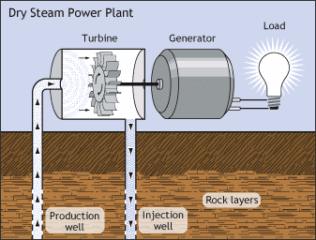

**2. Flash Steam Power Plants**

* Use **hot water (above 180°C)** from underground.
* When water rises to the surface, **pressure drops** causing some of the water to "flash" into steam.
* The steam is used to rotate turbines, while the rest of the water is returned underground.

**Most common** type of geothermal power plant worldwide.

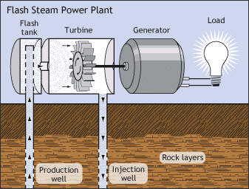

**3. Binary Cycle Power Plants**

* Suitable for **low to moderate temperature** water (below 180°C).
* Uses a **heat exchanger**: hot water heats a secondary fluid (like isobutane) with a **lower boiling point**.
* The vaporized secondary fluid drives the turbine.
* Water is then re-injected back into the Earth.

**Advantages**:

* Can be used in more locations.
* **Environmentally friendly** (closed loop, no emissions).

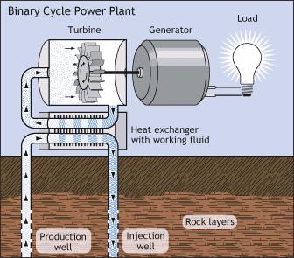

**4. Direct Use Applications**

Instead of converting geothermal energy to electricity, hot water is used **directly** for:

* **Space heating**
* **Greenhouse and fish farm heating**
* **Industrial drying** (like drying fruits)
* **Hot water supply** in spas and buildings

This method is **cost-effective** and widely used in many countries.

**5. Geothermal Heat Pumps (GHPs)**

* Used for **heating and cooling buildings**.
* These systems exchange heat with the ground using **pipes buried shallow** (10–100 feet).
* In winter: absorbs heat from the ground and transfers it into the building.
* In summer: removes heat from the building and transfers it to the ground.

**Highly energy-efficient** and useful in both hot and cold climates.

**III. Geothermal Energy Potential in India**

India lies in a **tectonically active zone**, which provides many potential sites for geothermal energy.

**Geothermal Resource Regions in India:**

|  |  |  |
| --- | --- | --- |
| **Region** | **State** | **Type** |
| **Puga Valley** | Ladakh | High geothermal gradient, ideal for power generation |
| **Manikaran** | Himachal Pradesh | Hot springs, suitable for direct heating |
| **Tattapani** | Chhattisgarh | Moderate temperature, ideal for small-scale projects |
| **Bakreshwar** | West Bengal | Hot water sources, potential for direct use |
| **Godavari Basin** | Andhra Pradesh | Deep geothermal sources |
| **Cambay Basin** | Gujarat | High temperature and pressure zones |

**IV. Current Status and Challenges in India**

**Current Status:**

* India has **300+ geothermal hot springs**.
* Estimated potential: **10,000 MW**, but **no commercial power plant** yet.
* Some pilot projects for **direct use** and **low-power generation** have been set up (e.g., Puga Valley project).

**Challenges:**

1. **Lack of Awareness**: Less attention compared to solar and wind.
2. **High Initial Costs**: Drilling wells is expensive.
3. **Technical Expertise**: Requires specialized knowledge and equipment.
4. **Exploration Risk**: Uncertainty in locating productive geothermal wells.
5. **Policy Support**: Need for stronger government backing and incentives.

**V. Future Potential and Recommendations**

* Can be a **reliable base-load energy source** (available 24/7).
* Great for **remote Himalayan and tribal areas** where grid power is unstable.
* Useful in **space heating, tourism, and agriculture** in cold regions like Ladakh and Himachal Pradesh.
* India can collaborate with countries like **Iceland, New Zealand, and the USA** to develop its geothermal capacity.

**3. Elaborate on the principles and utilization of OTEC, including the setting up of OTEC plants and thermodynamic cycles.**

**I. Introduction to OTEC**

**OTEC** stands for **Ocean Thermal Energy Conversion**.  
It is a method of generating electricity by using the **temperature difference between warm surface seawater and cold deep seawater**.

* Surface water (~25°C)
* Deep sea water (~5°C at 1000 meters depth)

Even a **small temperature difference** (minimum ~20°C) can be used to run a heat engine to produce electricity.

**II. Principle of OTEC**

The basic principle is based on **Rankine Cycle** — a thermodynamic cycle used in power plants.

* Warm surface water is used to **vaporize a working fluid** (like ammonia) with a low boiling point.
* The vapor expands and spins a **turbine**, generating electricity.
* Cold deep seawater is used to **condense** the vapor back into liquid.
* This cycle repeats continuously.

This process converts **solar energy stored in ocean water** into usable electricity — making it a **renewable energy source**.

**III. Types of OTEC Systems**

**1. Closed Cycle OTEC**

* Uses a **working fluid** like ammonia or propane.
* Warm surface water vaporizes the fluid → vapor turns turbine → cold water condenses it back.
* The fluid **circulates in a closed loop**.

**Advantages:**

* Simple to control
* No mixing of seawater

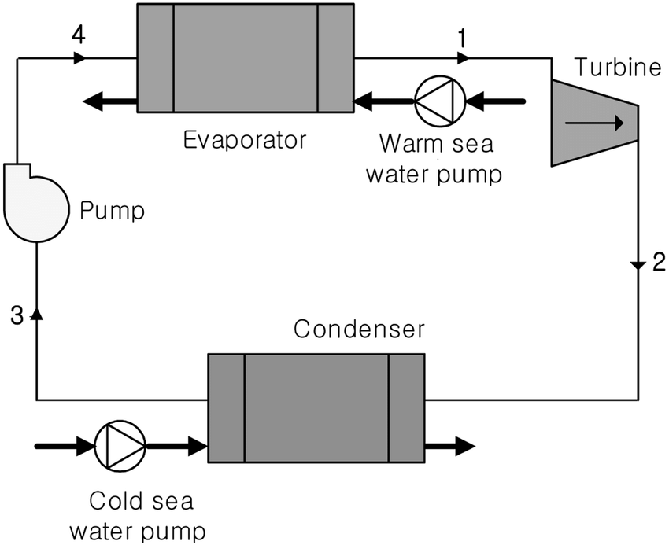

**2. Open Cycle OTEC**

* Warm seawater is **evaporated in a vacuum chamber** (due to low pressure).
* Steam drives a turbine.
* The steam is then **condensed using cold seawater**, producing **freshwater** as a by-product.

**Advantage:** Produces both electricity and **desalinated water**.

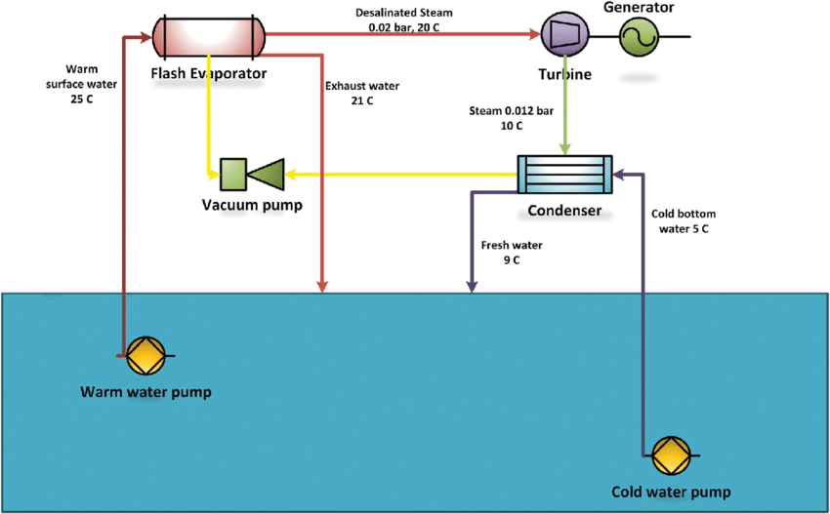

**3. Hybrid Cycle OTEC**

* Combines both open and closed cycles.
* Warm seawater is first flashed to steam (open cycle), then condensed using cold water in a heat exchanger (closed cycle).

**Advantage:** Generates more electricity and freshwater.

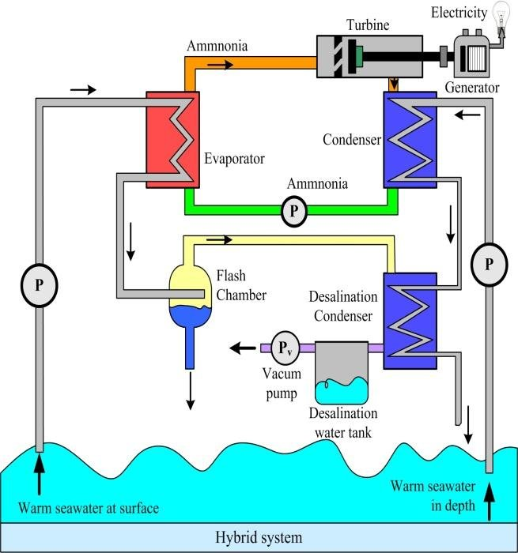

**IV. Setting Up of OTEC Plants**

To set up an OTEC plant, the following components and conditions are essential:

**1. Ideal Site Conditions**

* Temperature difference of **at least 20°C** between surface and deep water.
* Coastal or offshore areas with **deep sea access near shore**.
* Examples: Tropical coastal regions — **India (Tamil Nadu, Lakshadweep)**, **Hawaii**, **Philippines**.

**2. Main Components**

* **Warm Water Pipe**: Collects warm surface water.
* **Cold Water Pipe**: Brings cold deep water (from 1000 meters depth).
* **Evaporator**: Where warm water vaporizes working fluid.
* **Turbine and Generator**: Converts vapor energy into electricity.
* **Condenser**: Cold water cools the vapor back to liquid.
* **Pumps and Heat Exchangers**: Control flow and temperature exchange.
* **Platform or Barge**: For offshore OTEC plants.

**3. Onshore vs. Offshore Plants**

* **Onshore Plant**: Built on coast; easier to maintain.
* **Offshore Plant**: Floating barge; needs longer pipes and deep-sea anchoring.

**V. Thermodynamic Cycle (Simplified Explanation)**

OTEC mainly works on the **Rankine Cycle**:

1. **Heat Addition (Evaporation)**: Working fluid is vaporized using warm water.
2. **Expansion**: Vapor expands in turbine → does work → generates electricity.
3. **Heat Rejection (Condensation)**: Cold seawater condenses the vapor.
4. **Compression**: Liquid is pumped back to evaporator to repeat the cycle.

This is a **low-temperature thermal cycle**, so the efficiency is only around **2–3%** — but since oceans are vast and free, the fuel cost is zero.

**VI. Utilization of OTEC Energy**

**1. Electricity Generation**

* Used in **remote coastal or island communities**.
* Can be connected to the local grid or used for **standalone power**.

**2. Desalination**

* Open and hybrid cycle OTEC systems can produce **freshwater** from seawater.

**3. Air Conditioning**

* Cold deep seawater can be used for **seawater air conditioning (SWAC)** in coastal cities.

**4. Aquaculture and Agriculture**

* Cold water is nutrient-rich and can support **marine farming**.
* Waste heat from OTEC can be used for **greenhouse farming**.

**5. Hydrogen Production**

* OTEC electricity can be used to perform **electrolysis** and produce hydrogen fuel.

**VII. OTEC Potential in India**

* India has a long coastline and warm oceans.
* Best OTEC potential exists near **Lakshadweep Islands**, **Andaman & Nicobar**, and **Tamil Nadu coast**.
* The **National Institute of Ocean Technology (NIOT)** has already tested small OTEC plants in India.

**VIII. Advantages of OTEC**

* **Clean and renewable**: No greenhouse gas emissions.
* **Base-load power**: Works 24×7 unlike solar/wind.
* **Abundant source**: Oceans cover 70% of Earth’s surface.
* **Multi-use**: Electricity + desalinated water + cooling.

**IX. Disadvantages of OTEC**

* **High initial cost**: Offshore installation and maintenance are costly.
* **Low efficiency**: Only 2–3% due to small temperature difference.
* **Technical complexity**: Deep-sea pipe installation is difficult.
* **Limited locations**: Only works well in tropical zones.

**X. Conclusion**

OTEC is a **promising renewable technology** that uses the ocean’s natural heat gradient to produce clean electricity and freshwater. With vast ocean resources, India has great potential for future development. As technology improves and costs reduce, OTEC can become an important part of the **sustainable energy mix** in coastal and island regions.

**4. Compare and contrast the potential and conversion techniques of tidal and wave energy.**

**I. Introduction**

Tidal energy and wave energy are both forms of **ocean energy**.  
They are **renewable**, **predictable**, and **environmentally friendly**.

* **Tidal energy** comes from the **rise and fall of sea levels** due to the gravitational pull of the Moon and Sun.
* **Wave energy** comes from the **movement of surface water** due to wind blowing across the ocean.

**II. Tidal Energy – Potential and Conversion**

**A. Potential of Tidal Energy**

* **Highly predictable**: Tides follow a fixed pattern.
* Best locations: Narrow **bays**, **estuaries**, or **coastal regions** with high tidal range (difference between high and low tide).
* Countries with high potential: **UK, Canada, France, India (Gulf of Kutch & Cambay)**.

**B. Tidal Energy Conversion Techniques**

1. **Tidal Barrages**
   * Similar to a dam built across an estuary.
   * As the tide rises, water is stored in a basin.
   * When tide falls, water is released through turbines to generate electricity.
   * **Example**: La Rance Barrage, France.
2. **Tidal Stream Generators**
   * Like underwater wind turbines.
   * Placed in fast-flowing tidal streams or currents.
   * Turbines rotate with the flow and generate electricity.
3. **Dynamic Tidal Power (DTP)**
   * A long dam is extended into the ocean without enclosing an area.
   * Utilizes tidal phase differences to generate electricity.

**III. Wave Energy – Potential and Conversion**

**A. Potential of Wave Energy**

* Depends on **wind strength**, **duration**, and **distance** it blows over water (fetch).
* Strongest waves occur in **deep oceans**, **western coastlines** (e.g., Scotland, Portugal, Australia).
* Wave energy is **more variable** than tidal energy but has **higher power density**.

**B. Wave Energy Conversion Techniques**

1. **Point Absorbers**
   * Floating devices that move with wave motion.
   * Up-and-down motion drives a hydraulic system to generate power.
   * Example: PowerBuoy.
2. **Oscillating Water Columns (OWC)**
   * A partially submerged hollow structure.
   * Waves cause water inside to rise and fall, pushing air through a turbine.
3. **Overtopping Devices**
   * Waves fill a reservoir above sea level.
   * Water flows back into the sea through turbines.
4. **Attenuators**
   * Long floating structures aligned with wave direction.
   * Segments flex with waves, and the motion drives hydraulic generators.
   * Example: Pelamis Wave Energy Converter.

**IV. Common Advantages**

* **Clean and renewable**.
* **Reduces dependency** on fossil fuels.
* **No greenhouse gas emissions**.
* Good for **coastal and island regions**.

**V. Common Disadvantages**

* **High capital cost**.
* **Technology is still developing**.
* May affect **marine ecosystems** and **navigation routes**.

**VI. Conclusion**

Both **tidal** and **wave energy** are important for the future of **sustainable energy**.

* Tidal energy is **more predictable and reliable**, but **costly and location-specific**.
* Wave energy has **greater potential and flexibility**, but is **less predictable** and still under **technological development**.

Together, they can provide **clean, renewable, and decentralized power**, especially for **coastal regions and islands**.

**5. Evaluate the applications and economic aspects of mini-hydel power plants.**

**I. Introduction**

* Mini-hydel power plants are **small-scale hydroelectric systems** that generate electricity using the flow of water.
* They typically have a capacity of **up to 25 MW** in India (as per Ministry of New and Renewable Energy).
* They are a **clean, renewable, and decentralized** source of energy, especially suitable for **rural and hilly areas**.

**II. Applications of Mini-Hydel Power Plants**

1. **Rural Electrification**
   * Useful in powering **remote villages** where grid connectivity is difficult.
   * Helps provide **basic lighting, irrigation pumps, and communication** systems.
2. **Agricultural Use**
   * Powers **water pumps** for irrigation.
   * Reduces dependency on **diesel generators** or unreliable grid power.
3. **Industrial Support**
   * Supports **small-scale industries** (like food processing or textile units) in remote areas.
   * Provides **reliable and low-cost electricity**.
4. **Backup Power Supply**
   * Acts as a **reliable backup** in case of grid failure, especially for **hospitals, schools, and government buildings**.
5. **Integration with Smart Grids**
   * Can be connected to **local microgrids** to maintain power stability.
   * Enhances **energy access and resilience** in rural and semi-urban areas.
6. **Tourism and Eco-Development**
   * Some mini-hydro sites are used for **eco-tourism**.
   * Promotes sustainable development with **low environmental impact**.

**III. Economic Aspects of Mini-Hydel Power Plants**

**1. Capital Cost**

* Initial cost is **moderate to high**, depending on:
  + Site location
  + Water flow availability
  + Infrastructure (turbine, penstock, dam, etc.)
* Typically ranges from **₹5 to ₹8 crore per MW**.

**2. Operation & Maintenance Cost**

* Very **low recurring cost** compared to thermal or diesel plants.
* Requires minimal manpower after installation.
* Simple mechanical parts lead to **long lifespan (20–30 years)**.

**3. Cost per Unit**

* The **levelized cost of electricity (LCOE)** is low:
  + Around **₹2.50 to ₹5 per unit**, depending on site.
* More economical than **diesel or solar in some terrains**.

**4. Return on Investment (ROI)**

* Payback period is generally **6–10 years**.
* Grants and subsidies from **MNRE or international bodies** reduce the financial burden.

**5. Employment Generation**

* Provides **local employment** during construction and maintenance.
* Promotes **skill development** in engineering and technical fields.

**6. Financial Support**

* Government of India supports via:
  + **Subsidies up to 30%–70%** of capital cost.
  + **Soft loans** and **tax incentives** for private developers.
  + **Carbon credits** for clean energy generation.

**IV. Advantages of Mini-Hydel Plants**

* **Environmentally friendly** (no pollution, no fuel).
* **No large-scale displacement** or deforestation.
* **Low gestation period** (can be set up in 1–2 years).
* Can operate in **run-of-river mode**, no large dams needed.
* Provides **energy security** in remote locations.

**V. Limitations**

* **Site-specific**: Needs reliable water flow throughout the year.
* **Seasonal variation**: Output reduces in dry seasons.
* Initial **survey and planning** can be time-consuming.
* May need **grid connection or storage** to manage surplus power.

**VI. Conclusion**

Mini-hydel power plants play a **crucial role** in India's renewable energy mix.  
They are ideal for **distributed generation**, especially in **hilly, tribal, and forest regions**.  
From an **economic point of view**, they are **cost-effective in the long run** and support **rural development** and **employment**.

With proper planning and support, mini-hydro can **strengthen energy security** and promote **sustainable development** across the country.